WEEKLY UPDATE
ROLLING 4 - WEEK LOOKAHEAD

Beachcombers Corvette Club

December 21, 2025

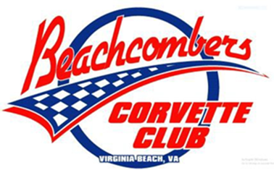

Note: The next Membership Meeting is Tuesday, January 6, 2026.
Until further notice, the hours for the library on the day of our Membership Meeting are now 5:30 pm – 7:30 pm but please note our meeting is still 6:15 – 7:30. This additional ½ hour will give the Board time to set up and allow for member socialization, merchandise questions and purchase of 50/50 tickets (sales end when meeting begins).
Looking in the Rear View Mirror


Hanukkah – 14th- 22nd

Vettes at New Realm (Social)
Looking Out the Front Windshield
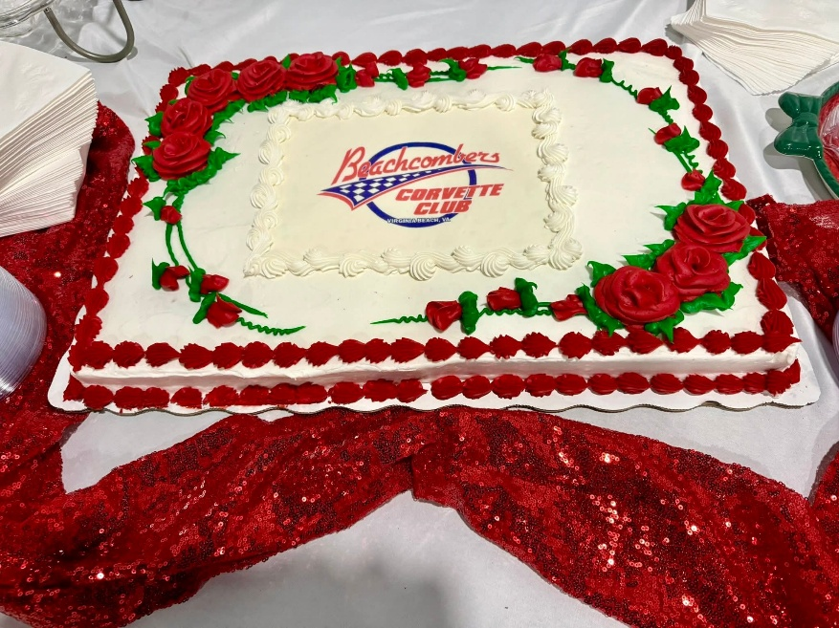

December Events


Christmas - 25th
We hope you’ve been good!

Dominion Raceway Track Attack

28th: Dominion Raceway Track Attack - Paced-lap events for those new to the track and/or those who don’t want to push themselves nor their vehicles too hard.
This Photo by Unknown Author is licensed under CC BY-NC
New Years Eve – 31st
Happy New Year and be safe!!!

January Events

New Years Day – 1st

BCC BUSINESS MEETING
6th: (6:15 – 7:30): Please note the January Business Meeting is on Tuesday, Jan 6, same time, place.

BCC Breakfast
14th (8:30 – 10:00): No signup required. This month we will meet at 8:30 am at the Brick House Diner, 941 Providence Square Shopping Center, VB, VA 23464.
Vettes at New Realm (Social)
20th (6:00 pm – 9:00 pm) 3rd Tuesday monthly from 6-9. Reserved parking for the first 20 Corvettes. All sports car friends are welcome! Full on-site dine-in menu and expansive beer and spirits selection.

BCC Board Meeting
21st : (6:00 – 8:00) - YNOT PIZZA at Landstown Shopping Center (3276 Princess Anne Road)
Other

Meetups
Here are links to other websites for area Cruise-Ins, Cars-and-Coffee, and other meetups:
  - Car Club Council of Hampton Roads - https://www.ccchr.org/
  - Car Crazy in Tidewater, VA - https://www.facebook.com/groups/1923014651308169
  - NCCC East Region –https://www.ernccc.org/

2026 Beachcombers Annual Cruise
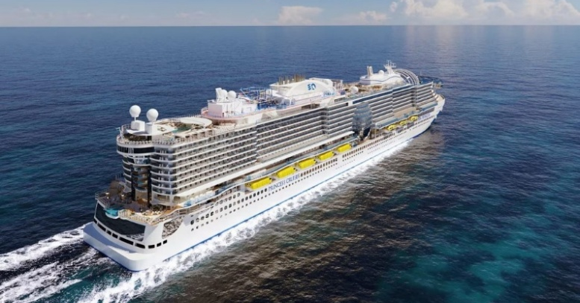
Beachcombers, we’re planning for next year’s Caribbean 🌴 adventure with a cruise aboard the new SUN Princess 🛳️. The dates for this cruise are Sunday, February 22 to Thursday, March 5. This cruise is unique in that you can book this as a seven-day cruise only, or a 4-day cruise only, or combine both for an eleven-day cruise. The below information provides the day-to-day itinerary. If you have questions please contact Joe Wryk at 757-342-9207 for more information. If you’re ready to book a cabin please call our Princess Vacation Planner, Michael Blair, at 800-901-1172 ext. 41716 or 661-753-0303 ext. 41716. Make sure you let him know you are with the Beachcombers Corvette Club.

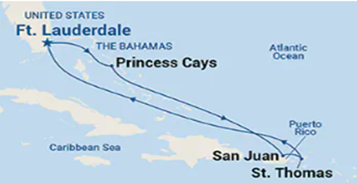
7-Day Cruise – Feb 22 – Mar 1

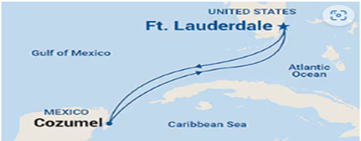
4-Day Cruise – Mar 1 – Mar 5


